Inheritance

📌 Definition:
# Source: AI Source: Provided by: [Data Path: Persons Table -> ID Column: 1, Name_En Column: Motasem Essam] -> From: [ChatGPT] on [12/9/2025]
Inheritance is an OOP principle that allows a class (child/subclass) to inherit properties and behaviors from another class (parent/superclass).

🧠 Simple idea:
# Source: AI Source: Provided by: [Data Path: Persons Table -> ID Column: 1, Name_En Column: Motasem Essam] -> From: [ChatGPT] on [12/9/2025]
Inheritance = “Reuse and extend existing code” ♻️

🔍 Key characteristics:
# Source: AI Source: Provided by: [Data Path: Persons Table -> ID Column: 1, Name_En Column: Motasem Essam] -> From: [ChatGPT] on [12/9/2025]
- 🔗 Creates a parent-child relationship between classes
- ♻️ Promotes code reuse
- ➕ Allows adding new features in the child class
- 🔄 Supports hierarchical structure
- 🧩 Helps organize code efficiently

📌 Example (Java-style):
# Source: AI Source: Provided by: [Data Path: Persons Table -> ID Column: 1, Name_En Column: Motasem Essam] -> From: [ChatGPT] on [12/9/2025]
Parent class:
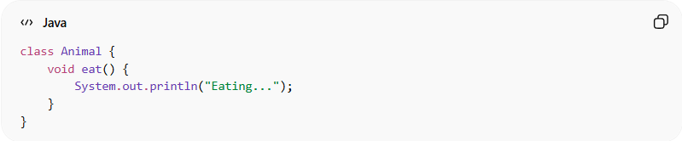
class Animal {
void eat() {
System.out.println("Eating...");
}
}

Child class:
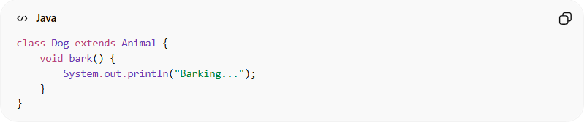
class Dog extends Animal {
void bark() {
System.out.println("Barking...");
}
}

Usage:
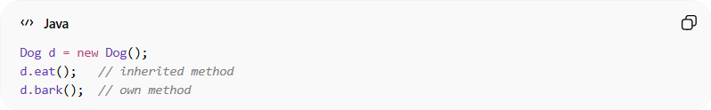
Dog d = new Dog();
d.eat(); // inherited method
d.bark(); // own method
👉 The Dog class:
- 🔁 Inherits eat() from Animal
- ➕ Adds its own method bark()

⚙️ Types of inheritance:
# Source: AI Source: Provided by: [Data Path: Persons Table -> ID Column: 1, Name_En Column: Motasem Essam] -> From: [ChatGPT] on [12/9/2025]
- 🟢 Single inheritance
- 🟢 Multilevel inheritance
- 🟢 Hierarchical inheritance
- ⚠️ Multiple inheritance (not directly supported in some languages like Java, but possible via interfaces)

🎯 Why inheritance is important:
# Source: AI Source: Provided by: [Data Path: Persons Table -> ID Column: 1, Name_En Column: Motasem Essam] -> From: [ChatGPT] on [12/9/2025]
- ♻️ Reduces code duplication
- 🧱 Improves code organization
- ⚡ Makes development faster
- 🔗 Builds relationships between classes

🎯 Summary:
# Source: AI Source: Provided by: [Data Path: Persons Table -> ID Column: 1, Name_En Column: Motasem Essam] -> From: [ChatGPT] on [12/9/2025]
Inheritance allows a class to reuse and extend another class’s features, making code more efficient, organized, and reusable.

